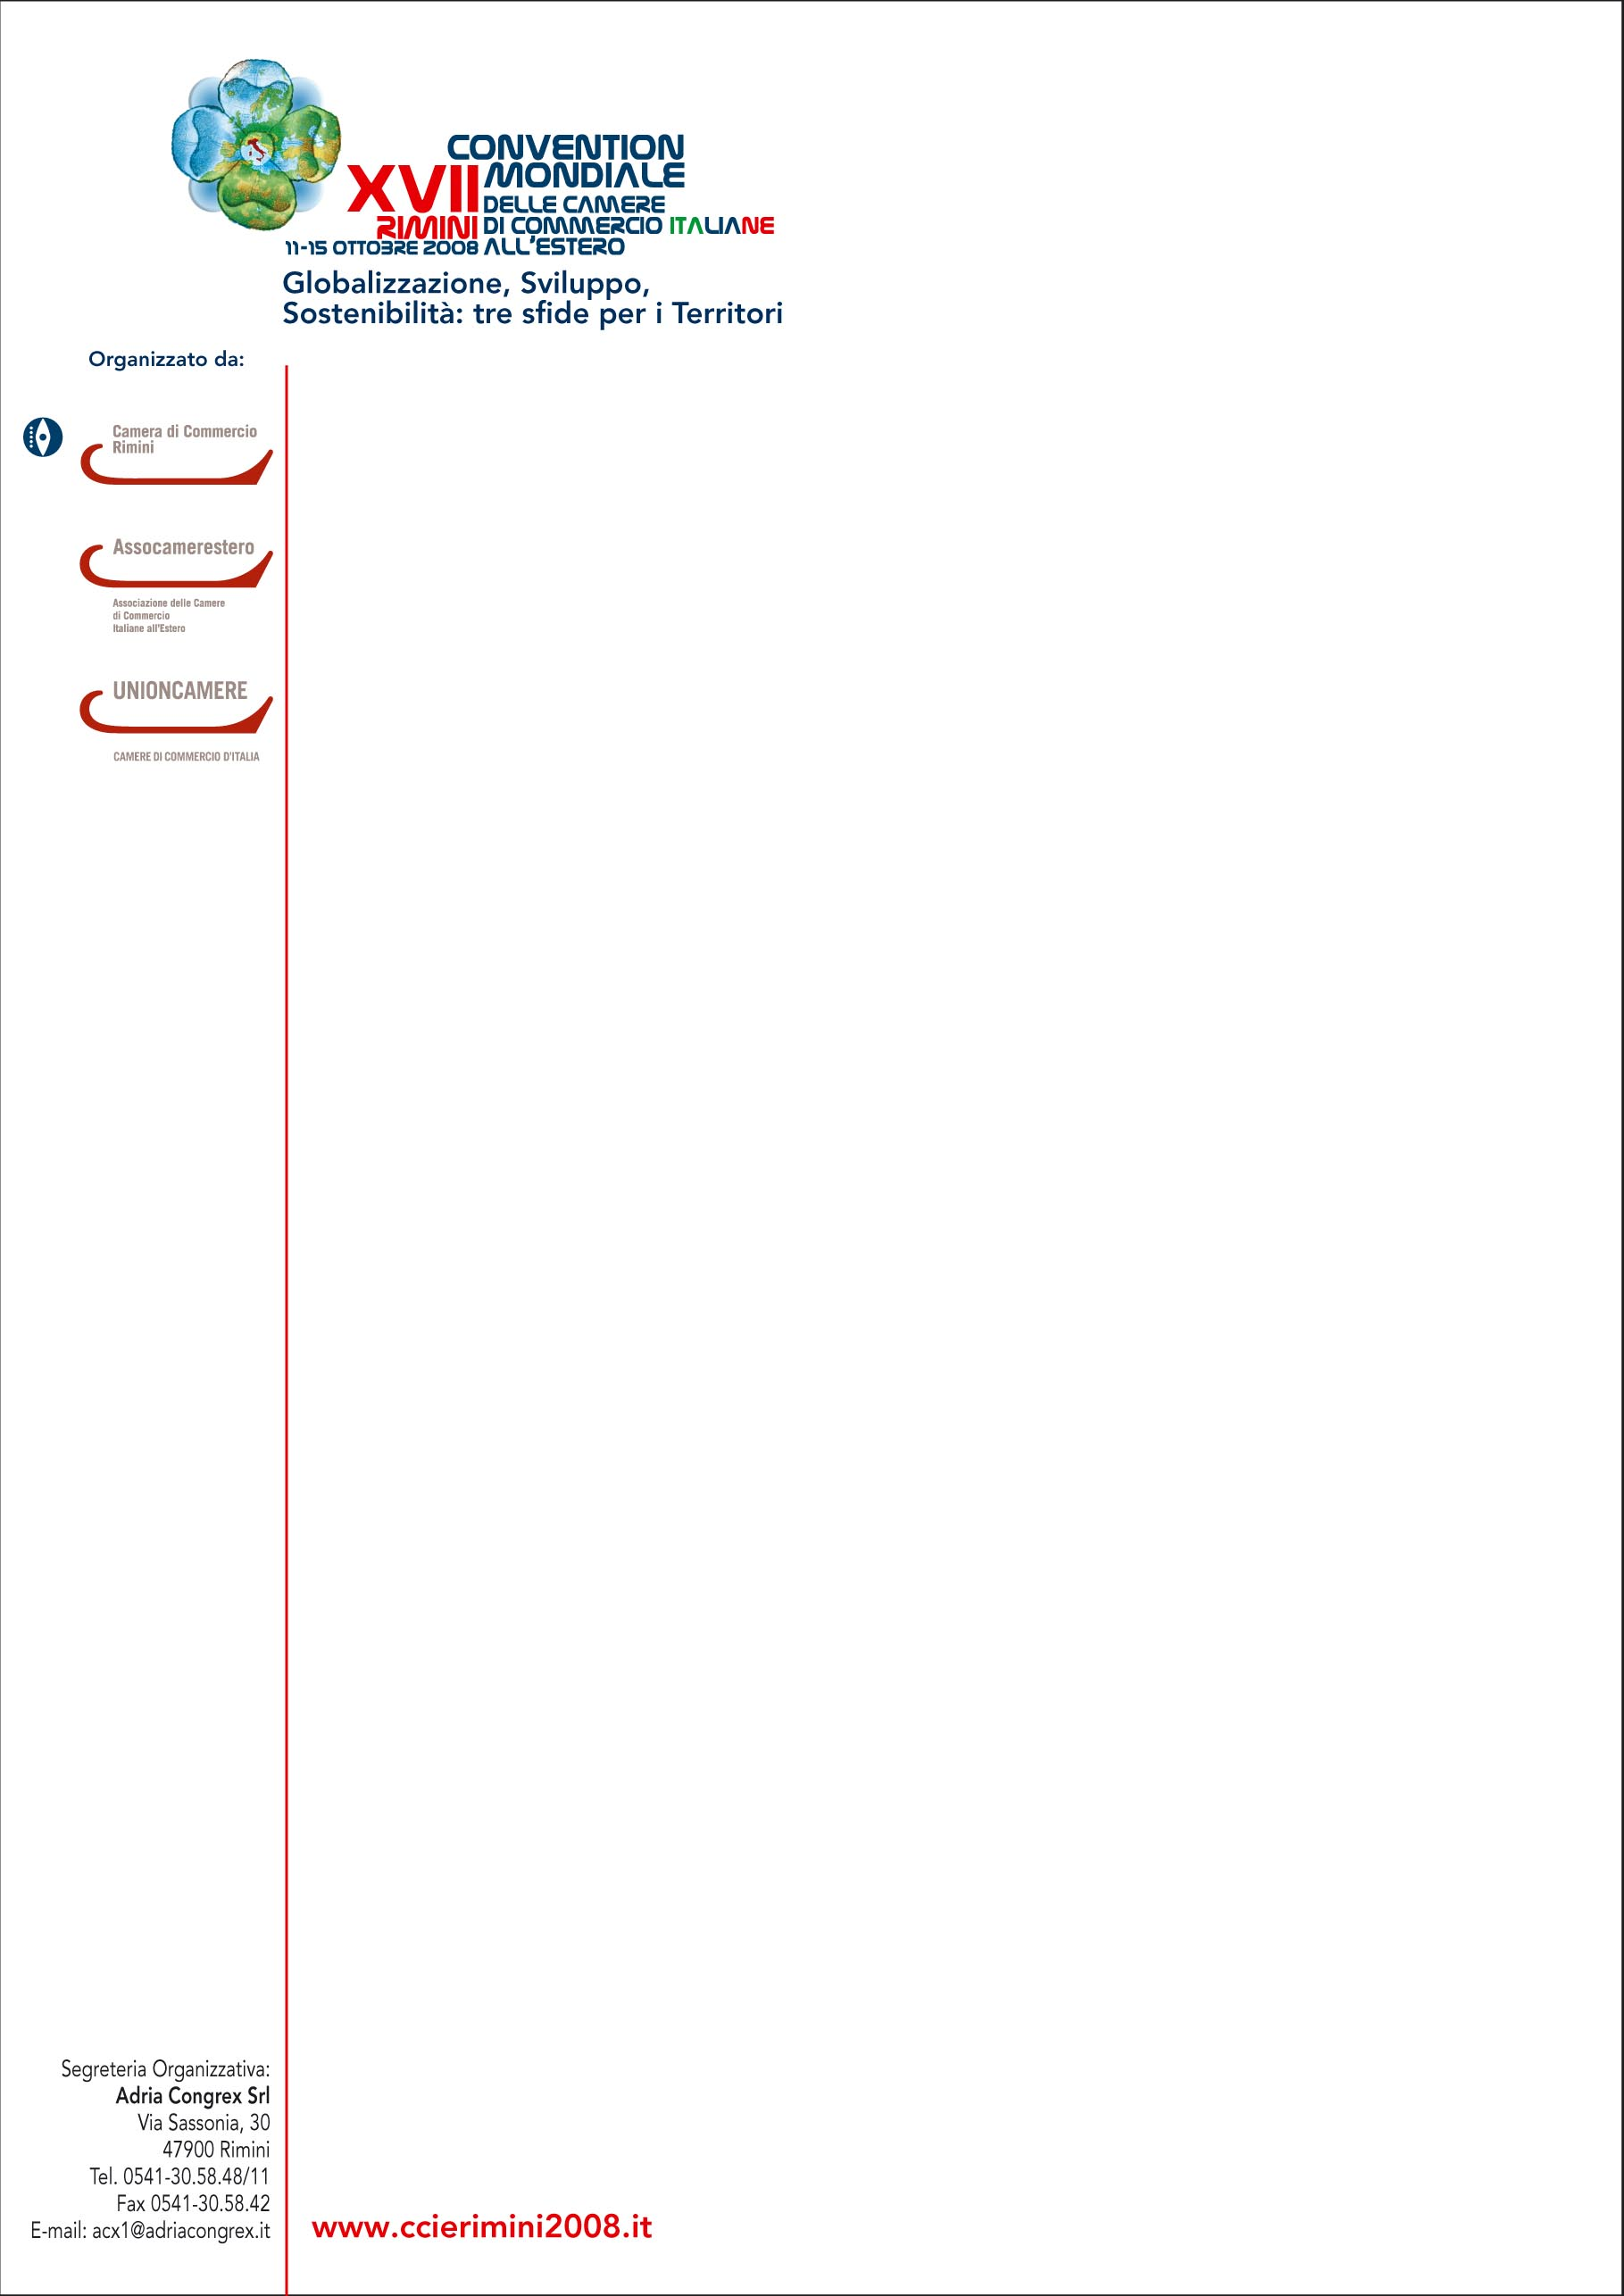
EXPORT PER AREE GEOGRAFICHE - VALORI IN EURO
 | 1° SEMESTRE 2008 |  |  |  |  |  |  |  |  |  |  |  |  | 1° SEMESTRE 2007
 | EUROPA |  | DI CUI UE 27 |  | AFRICA |  | AMERICA |  | ASIA |  | OCEANIA |  | TOTALE EXPORT 1° SEM. '08 | TOTALE EXPORT 1° SEM. '07 | VAR. % EXPORT '08-'07
Emilia Romagna | 17.292.947.208 |  | 14.422.920.387 |  | 1.043.434.333 |  | 2.851.717.556 |  | 3.071.318.273 |  | 353.318.162 |  | 24.612.735.532 | 22.547.617.931 | 9,2%
Piacenza | 746.577.383 |  | 596.760.579 |  | 120.003.232 |  | 130.380.563 |  | 238.148.051 |  | 10.876.048 |  | 1.245.985.277 | 1.081.319.870 | 15,2%
Parma | 1.715.912.416 |  | 1.441.338.388 |  | 126.060.504 |  | 238.251.269 |  | 274.972.687 |  | 22.361.990 |  | 2.377.558.866 | 2.128.806.757 | 11,7%
Reggio Emilia | 3.352.051.109 |  | 2.871.545.663 |  | 174.173.719 |  | 414.422.127 |  | 430.678.005 |  | 75.541.475 |  | 4.446.866.435 | 4.057.172.874 | 9,6%
Modena | 3.822.967.842 |  | 3.132.426.014 |  | 201.635.843 |  | 864.013.188 |  | 680.144.461 |  | 98.237.114 |  | 5.666.998.448 | 5.179.984.097 | 9,4%
Bologna | 3.834.488.537 |  | 3.162.880.463 |  | 203.491.087 |  | 750.745.816 |  | 843.424.813 |  | 82.913.482 |  | 5.715.063.735 | 5.287.425.075 | 8,1%
Ferrara | 813.906.512 |  | 730.906.741 |  | 45.512.488 |  | 156.435.610 |  | 136.441.907 |  | 10.525.902 |  | 1.162.822.419 | 1.248.822.826 | -6,9%
Ravenna | 1.260.469.408 |  | 1.082.448.436 |  | 80.047.586 |  | 77.536.764 |  | 189.865.390 |  | 17.904.737 |  | 1.625.823.885 | 1.402.436.192 | 15,9%
Forlì Cesena | 1.102.598.688 |  | 908.848.707 |  | 73.959.679 |  | 122.435.509 |  | 204.455.483 |  | 22.656.018 |  | 1.526.105.377 | 1.439.213.572 | 6,0%
Rimini | 643.975.313 |  | 495.765.396 |  | 18.550.195 |  | 97.496.710 |  | 73.187.476 |  | 12.301.396 |  | 845.511.090 | 722.436.668 | 17,0%
Nord Est | 41.502.351.970 |  | 34.205.201.978 |  | 2.204.358.570 |  | 6.582.616.257 |  | 6.984.029.769 |  | 706.267.928 |  | 57.979.624.494 | 54.660.984.345 | 6,1%
Italia | 134.266.266.535 |  | 111.888.451.117 |  | 8.607.271.777 |  | 18.817.542.381 |  | 22.596.768.369 |  | 2.909.114.990 |  | 187.196.964.052 | 176.782.904.520 | 5,9%
Fonte: Datawarehouse Istat Coeweb

Comunicato stampa n. 3, 7 ottobre 2008

